Practical No 6

Aim : Study and implement identity and Access management (IAM) Theory :

[Identity and Access Management (IAM)](https://www.geeksforgeeks.org/identity-and-access-management-iam/) is a combination of policies and technologies that allows organizations to identify users and provide the right form of access as and when required. There has been a burst in the market with new applications, and the requirement for an organization to use these applications has increased drastically. The services and resources you want to access can be specified in IAM. IAM doesn’t provide any replica or backup. IAM can be used for many purposes such as, if one want’s to control access of individual and group access for your AWS resources. With IAM policies, managing permissions to your workforce and systems to ensure least-privilege permissions becomes easier.

Output :

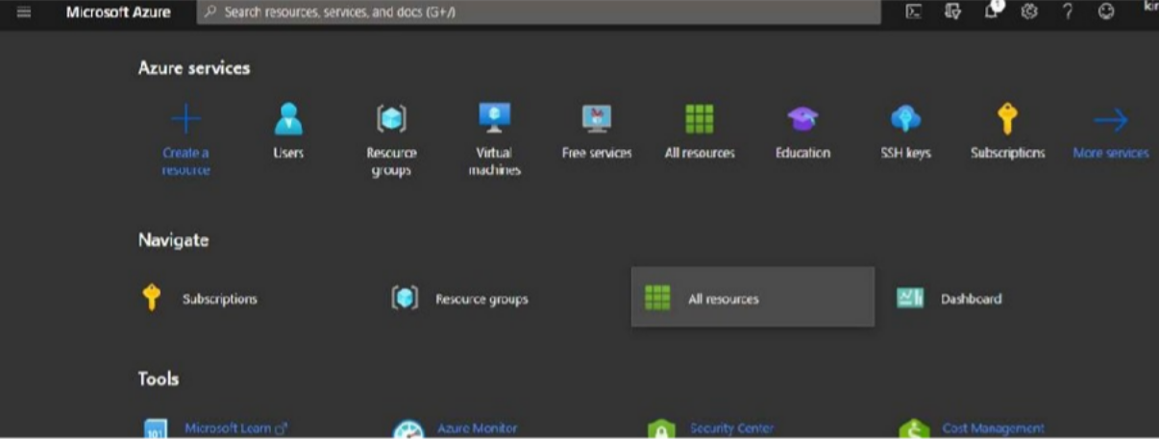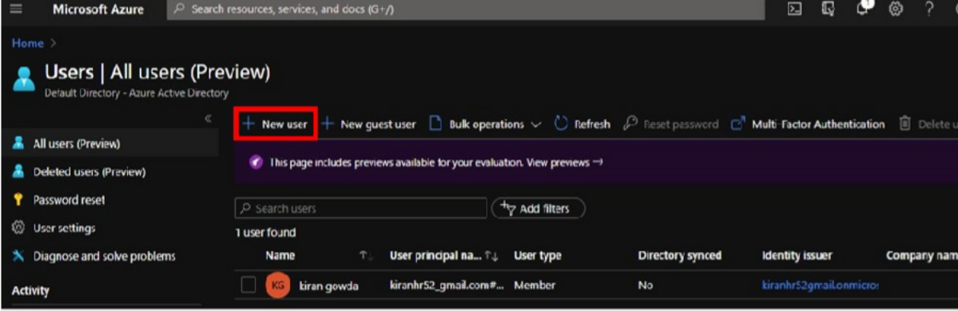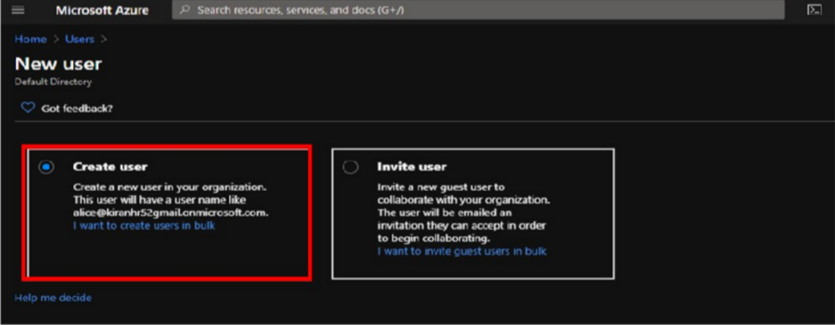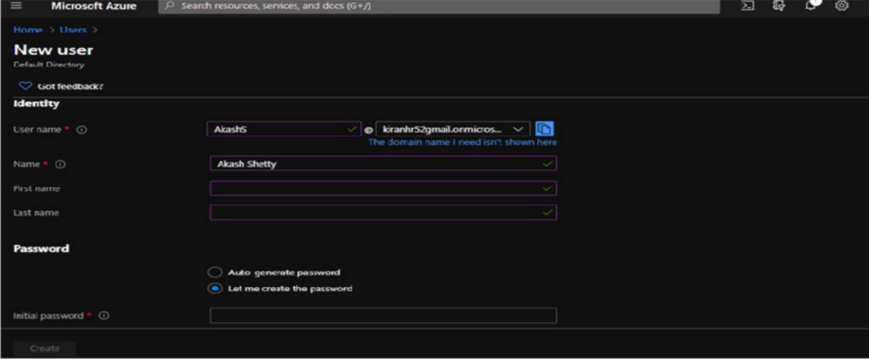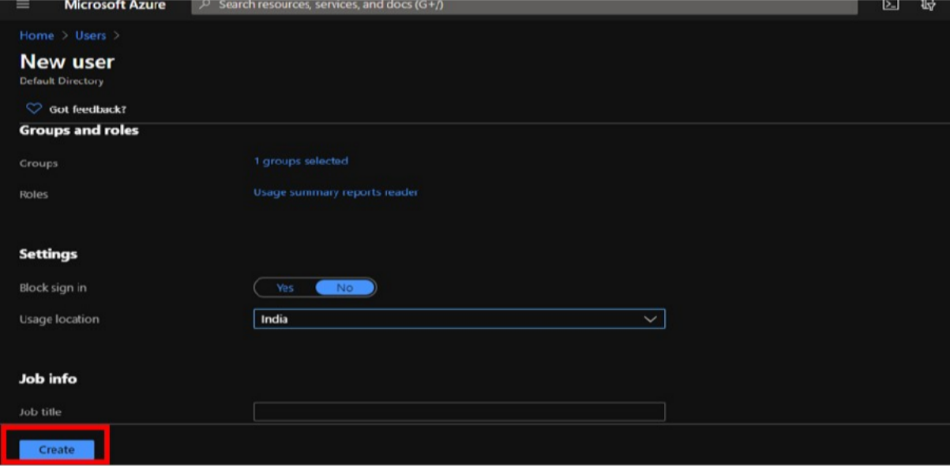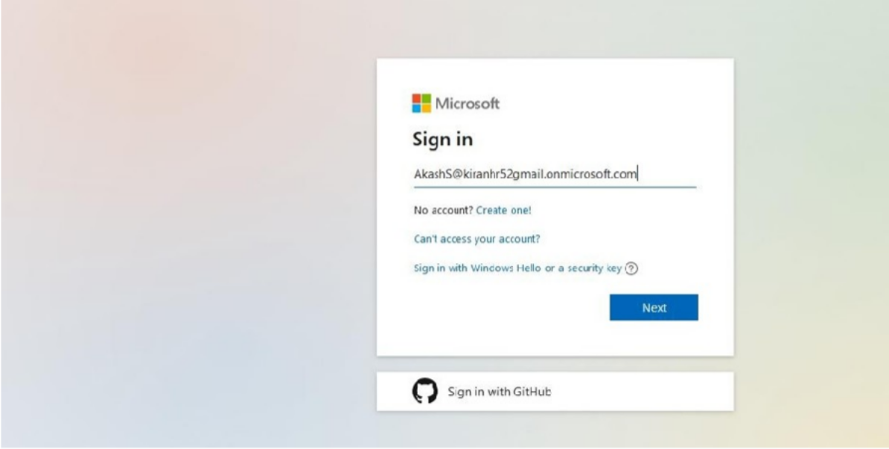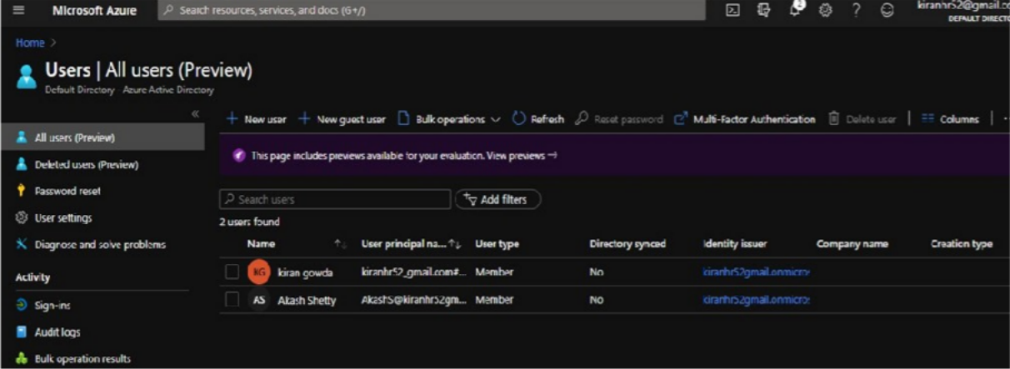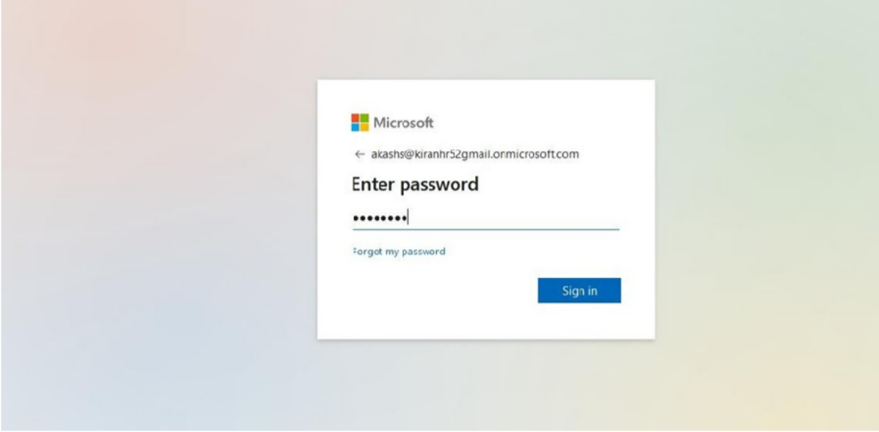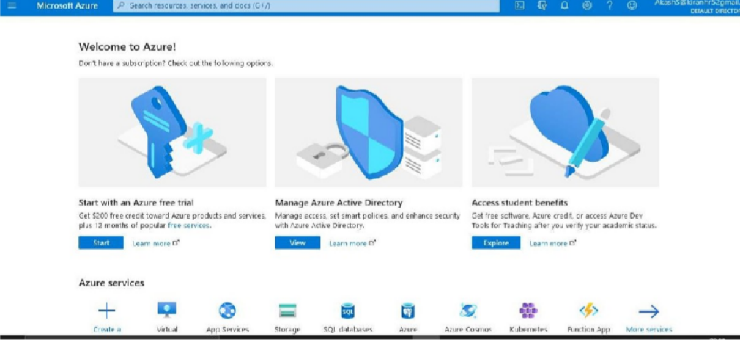

Conclusion : Successfully Performed Identity management and Access Management